NAME: IBRAHIM DOBA

MATIC NO: 2017/1/68024PL

DATE: 5/10/2021

COURSE: GEL 419

DEPARTMENT: GEOLOGY

Question:

Discuss the mineral resources of BIDA basin and the Niger Delta state.

**The Bida Basin in north-central Nigeria: sedimentology and petroleum geology**

The Bida Basin, also known as the Mid-Niger or Nupe

Basin, is located in west-central Nigeria. Nigeria’s current proven petroleum reserves are about 38 billion barrels of oil and about 190 trillion standard cubic feet of gas and derive solely from the Niger Delta on- and offshore. Exploration campaigns in the inland basins have been undertaken with the aim of expanding the national exploration and production base

and adding to the proven reserves. Inland basins in

Nigeria comprises the Anambra and Dahomey Basins in

the south, the Lower, Middle and Upper Benue Trough,

the Chad (Bornu) Basin in the NE, the Bida Basin, and

the Sokoto Basin in the NW. Exploration of the inland

basins have not been commercially successful to-date,

principally because of the lack of knowledge of their

geology and also because of their distance from the

existing infrastructure. For these reasons, many

international companies have turned their focus away

from the onshore to frontier deep-water and ultra-deep

water offshore.

The inland basins of Nigeria constitute one set of a

series of Cretaceous and later rift basins in Central and

West Africa whose origin is related to the opening of the

South Atlantic Commercial hydrocarbon

accumulations have recently been discovered in Chad,

Niger and Sudan within this rift trend. In SW Chad,

development of the *Doba* discovery (with estimated

reserves of about 1 billion barrels) has resulted in the

construction of a 1070 km long pipeline to the Atlantic

coast. In the Sudan, “giant” fields (including *Unity 1* and *2*, *Kaikang* and *Heglig*) have been discovered in the Muglad Basin.

These discoveries have encouraged geological,

geochemical and geophysical studies in the Nigerian

inland basins. This paper attempts to evaluate the

sedimentological characteristics of the deposits in the Bida basin.

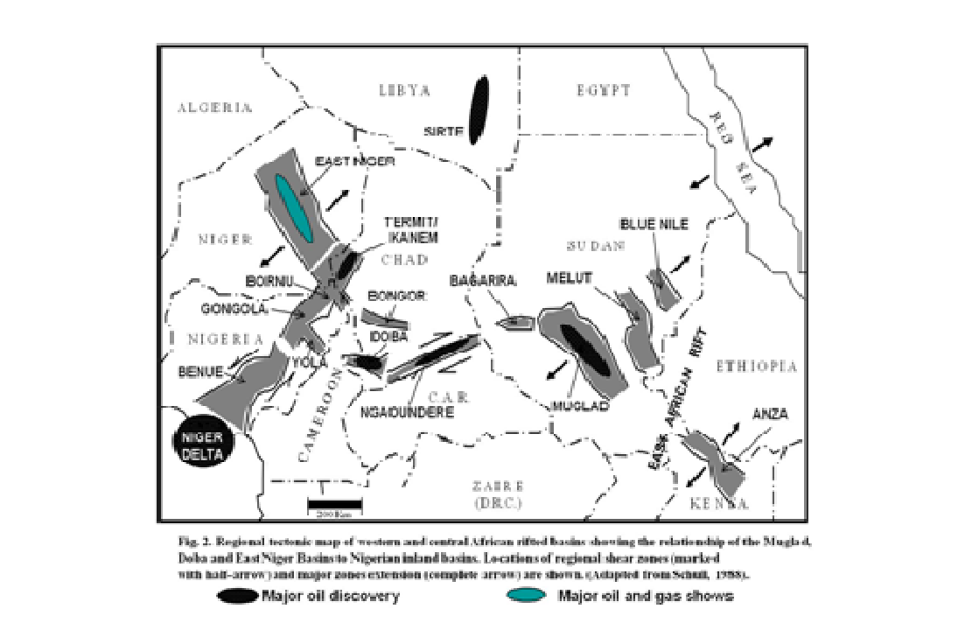

**The Bida Basin**

The Bida Basin is a NW-SE trending intracratonic

structure extending from Kontagora in Niger State in the

north to the area slightly beyond Lokoja in the south

It is delimited in the NE and SW by the basement complex and merges with the Anambra and Sokoto Basins to the SE and NW respectively.

Its sedimentary fill comprises post-orogenic molasse and

thin unfolded marine sediments. The basin is a gently down-warped trough whose origin is closely connected with Santonian orogenic movements in SE Nigeria and the Benue valley. The basin trends perpendicular to the main axis of the Benue Trough and the Niger Delta Basin and is regarded as the

NW extension of the Anambra Basin, both of which were

major depocentres during the third major transgressive

cycle in the Late Cretaceous Interpretations of

Landsat images and borehole logs, as well as

geophysical data suggest that the basin is bounded by a system of linear faults trending NW. Gravity studies point to a series of

central positive anomalies flanked by negative anomalies,

similar to the adjacent Benue Trough and typical of rift

structures.

The Benue Trough can be interpreted as the “failed

arm” of a triple junction located beneath the present

position of the Niger Delta during the Cretaceous. The

trough is filled with over 5000 m of predominantly Aptian

to Maastrichtian sediments. The Lower Benue Trough

including the Anambra Basin is the southern extension of

the Bida Basin. Gravity studies in the Bida Basin put the

maximum thickness of the sedimentary successions at

about 3.5 km in the central axis. Although the

basin has not been fully covered by seismic

investigations and remains undrilled, both ground and

aeromagnetic studies have outlined its first-order

structure. A recent spectral analysis of the residual total magnetic

field in different sections of the basin showed that the

average depth to basement is about 3.4 km, with

sedimentary thicknesses of up to 4.7 km in the central

and southern parts of the basin.

In general, sediment thickness decreases

smoothly from the centre to the flanks of the basin

Previous studies of the Bida Basin and the micropalaeontological studies of (Jan du Chene *et al*., 1978), who documented the palynomorph foraminiferal associations and interpreted

palaeodepositional environments of the Lokoja and Patti

Formations as being generally of shallow marine

deposits.

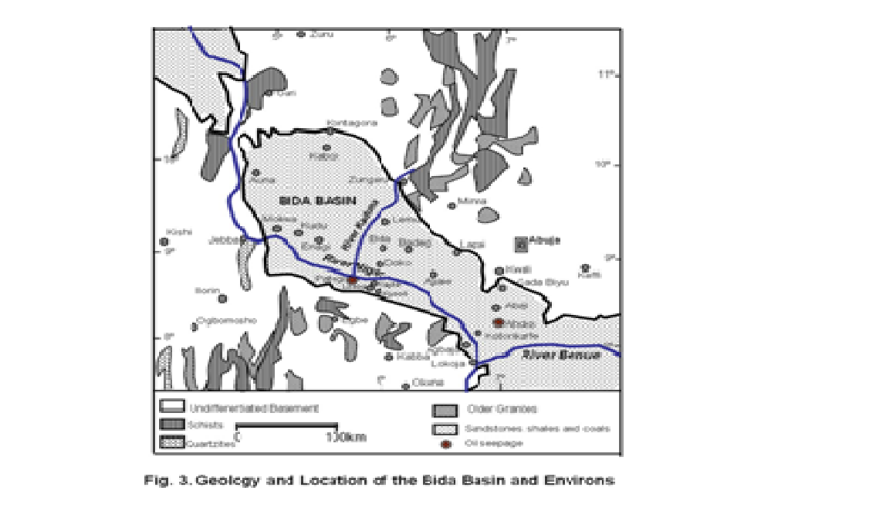

**Stratigraphy and Paleogeography**

The Bida Basin can be divided into Northern and

Southern (or Lokoja) Sub-Basins. The stratigraphic

succession of the Bida Basin, collectively referred to as

the Nupe Group by Adeleye, comprises a NW-SE

trending belt of Upper Cretaceous sedimentary rocks,

deposited as a result of subsidence during Cretaceous

opening of the South Atlantic Ocean. Sinistral offset

along the NE-SW axis of the Benue Trough appears to

have been translated to north-south and NW-SE trending

shear zones to form the Bida Basin at high angle to the

Benue Trough.

The sedimentary fill of the Benue Trough consists of

three unconformity-bounded depositional sequences

and the Bida and Anambra regions were

platforms until the Santonian. Pre-Santonian rocks are

recorded in parts of the older Benue Trough and in the

southern Anambra Basin. Collapse of the Mid-Niger and

Anambra platforms led to the initiation of Upper

Cretaceous deposition commencing with the fully-marine

shales of the Campanian Nkporo and Enugu formations,

which may have lateral equivalents in the Lokoja

Formation of the Bida Basin Overlying the

Nkporo Formation in the Anambra Basin is the Mamu

Formation consisting of shales, siltstones, sandstones

and coals of fluvio-deltaic to fluvio-estuarine origin

(Nwajide and Reijers, ) whose lateral equivalents in

the Bida Basin are the conglomerates, cross-bedded and

poorly sorted sandstones and claystones of the Lokoja

and Bida formations and part of the Patti Formation.

The Mamu Formation is overalin by sandstones of the

Lower Maastrichtian Ajalli Formation, laterally equivalent

to the Patti, Sakpe and Enagi formations of the Bida

Basin. The Ajalli sandstones are well sorted quartz

Arenites that are commonly interbedded

with siltstones and claystones and are similar to the

lithologies of the Patti and Enagi formations. The Patti

and Enagi formations are overlain by the Upper

Maastrichtian Agbaja and Batati formations (lateral

equivalents) These consist of oolitic, pisolitic and concretionary ironstones deposited within a continental to shallow marine setting (Ladipo et al.,) .

The nature of the sedimentary succession in the Bida

Basin suggests that full-marine conditions were not

established here, compared to the marine sedimentation

which was established for the Campanian Nkporo

Formation in the adjacent Anambra Basin during that

transgressive cycle. A comparison of sedimentary

thicknesses in the two basins indicate that the Anambra

Basin fill reaches up to 8km compared with an average of

3.4 km of sediment in the Bida Basin.

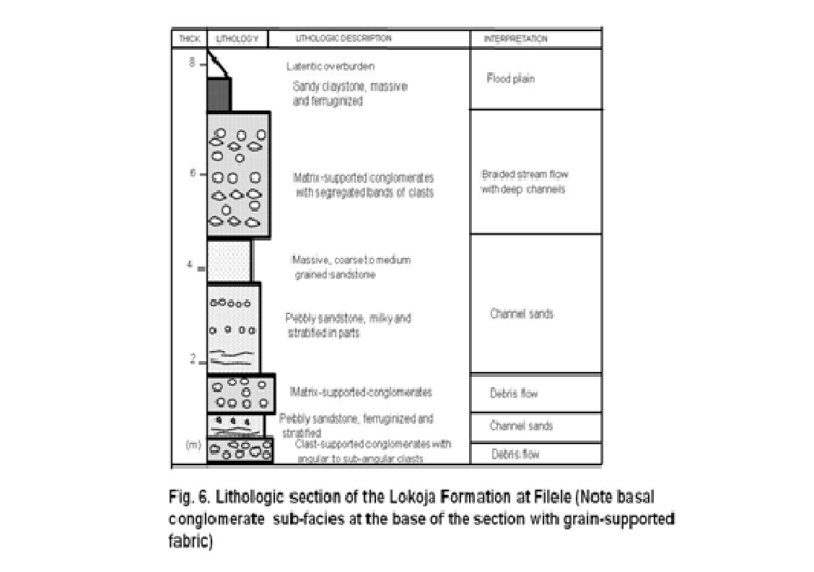

**MATERIALS AND METHODS**

A geological traverse covering the entire basin was

undertaken by the authors, paying particular attention to

the Southern Bida Basin where sections are better

exposed and more accessible. Exposed stratigraphic

sections at Lokoja, Agbaja, Ahoko and Abaji were logged

accordingly, and facies units interpreted during the

logging process based on sediment grain sizes and

textures, sedimentary structures, fossil content and

mineral assemblages. Available geochemical data were

reviewed and juxtaposed against the sedimentological

data derived from the field logging to interpret the

hydrocarbon prospectivity of the basin comprising the

major petroleum system elements of source rocks,

reservoir rocks and migration and trapping possibilities.

Geological cross sections were constructed to deduce

deeper sections of the basin that will require detailed

prospectively investigations during future drilling

campaigns.

**Petroleum geology**

**Source Rocks**

The Bida Basin has potential source rocks composed of

carbonaceous shales, intercalated with

sandstones and clay indicate that organic matter in

these source rocks are in the early-mature stage of gas

generation and may have reached peak stages in the deeper portions of the basin. Further geochemical.

kerogen in the Patti Formation is dominated by Type III

material (vitrinites) with some Type II (liptinites) and Type

lV (inertinites). Vitrinite reflectance and fluorescent

properties of investigated macerals suggest immature to

marginally mature kerogens with Ro values varying

mostly from 0.42 to 0.63%. T0C values range from 0.17

to as high as 3.8% (mean = 2.3%). Rock Eval data for the

shale support the microscopic evidence for the

prevalence of land-derived humic kerogen derived from

terrestrial organic matter. The results indicate that the

shales are gas prone with minor oil generation potential.

**Reservoir Facies**

The stratified nature of the shales and sandstones

provides likely favourable pathways for migration of fluids into potential reservoir rocks made up mainly of fluvial,

shelf and flood plain sandstones in the Lokoja and the

Patti formations. The relatively well-sorted sandstone units of the tidally influenced facies of the Patti Formation has been observed as better characterized reservoir rock compared to the fluvial Lokoja Sandstone with the prevalence of alluvial fans, containing poorly sorted massive conglomeratic sandstone proximal to the

basement. These continental alluvial fans with obvious

clogging of the pore throats by clays and clay-filled

minerals will be responsible for the inferred reduced

porosity and permeability in the Lokoja Sandstone than in

the tidally influenced facies (obvious from observed

herringbone and cross-stratifications) of the Patti

Formation which may provide better reservoir possibilities

at greater depths.

**MINERIAL RESOURCES OF NIGER DELTA**

**MINING IN THE NIGER DELTA**

It is because of oil and gas that the international community is interested in the Niger Delta, but for Local People, sand, soil and clay, periwinkle shells and salt are no less important. However, a number of mineral resources are mined in the Niger Delta but oil is the most important. Important in terms of its international demand, of its value to the Nigerian economy and of the impact that oil mining has upon the human ecology of the area. No one can live in the Niger Delta without becoming aware that oil is the political, economic and environmental issue that eclipses all others. Next to oil, its associate product, gas, is the most important, and likely to become more so in years to come.

The previous chapters have discussed renewable natural resources. If their exploitation is managed properly - so that the ecosystems, which produce them, remain viable - they can be produced indefinitely, be they fish, bushmeat, timber or agricultural produce. Thus, fishermen, hunters, loggers and farmers have an incentive to manage these ecosystems sensibly in order to ensure they continued supply of what they need.

Mineral resources, on the other hand, are non-renewable. Their exploitation is not dependent upon the viability of ecosystems, the degradation of which has little, if any, impact upon their supply. In fact, in modern times the commercial exploitation of minerals has shown scant respect for the viability of ecosystems because the short-term maximization of returns on capital does not take into account the cost of the ecological damage caused by mining. This is a cost borne most heavily by Local People (host communities) and not by the owners of mining companies. For example, large areas of Europe remain scarred by nineteenth century mining activity.

**OIL MINING IN THE NIGER DELTA: THE MORAL ISSUE**

Nigeria has an undemocratic and corrupt political process. The willingness with which mining companies tend to exploit this process, springs from the historical entrenched culture of the Western oil companies in their relationships with third world countries. **This oil industry culture is founded on five assumptions:**

* that profit maximization is the only basis upon which a company can be run, so that any expenditure beyond what is required to get out the oil is resisted;
* that a 'deal' can be made with governments only, regardless of the government's legality or morality, and regardless also of the wishes or needs of the Local People;
* that once an arrangement has been made with a government a mining company can do what it likes-in fact, to act as if it is a government agency;
* that the 'market' (i.e., the industrialized world) has a right to have the resources it wants, at the lowest possible price, and regardless of the costs to the Local People who are obliged to play host to mining companies; and
* that 'we', the mining companies, know best and are acting responsibly.

Generally, neither the companies nor the governments with whom they associate, (from both the first and the third worlds) are willing to accept any divergence from this culture which is re-enforced with a mixture of cynical public relations and intimidation. It is fair to say that the adverse impacts of mining upon the lives of host communities (and, for that matter, the extravagant use of mineral resources by the industrialized world) arises more from this immoral culture (this wickedness) than from anything else. Thus, until there is a culture shift by mining companies towards an acceptance of some of the moral responsibility for the injustices that the host communities suffer, mining will continue to be an activity that is at best unwelcomed, and in most cases feared by Local People. This fear is especially the case in countries where governments are able to act with impunity against the interests of their own citizens.

**THE GEOLOGY OF THE NIGER DELTA**

As explained in chapter three there have been two Niger Deltas over geological time. The first delta was deposited in tertiary times when the Niger flowed into the tertiary sea, some 60 to 150 million years ago, at least 30m higher than the modern sea. The second delta is made up of deposits left from the lower quaternary era to the present day.

The drop in sea level in quaternary times (commencing about 2 million years ago) caused the Niger to erode a wide flood plain through the tertiary deposits between Yenegoa and Onitsha. The sudden drop from the tertiary to the quaternary deposits is obvious through much of the region, creating two distinct terraces. This is particularly obvious in Port Harcourt at the Bonny River, where a cliff rises thirty feet high above seventy feet of deep water.

This picture is further complicated by what is known as Localised Uplift caused by earth movements. This is why, for instance, the Sombrero River/Ogoni Terrace, at 1518m above sea level, is a few metres higher than the rest of the tertiary terrace.

Because the delta is made up of deposits carried down by the vast Niger/Benue basin it covers a huge area: about 75,000 km² onshore, 75,000 km² offshore on the continental shelf, and about 90,000 km² beyond the continental shelf on what is known as the Guinea Abyssal Plain. This makes a total area of about 240,000 km², only slightly smaller than the entire United Kingdom. The immense weight of the delta (where, at its thickest, the sediments are over 15 km thick) compresses the lower layers (strata) of sediment and also depresses the earth's crust, which periodically subsides as a result. Each time this subsidence occurs, the front (seaward) portion of the delta slumps downwards and forwards creating a fault, introducing sea water (and thus marine conditions) to be brought inshore. Following the subsidence there is a period of stability when fresh riverine deposits are laid over and beyond the older slumped part of the delta, until there is another subsidence.

As a result of these alternating processes, a cross-section of the delta shows an inter-leaving of strata of marine and river sediments. These are roughly horizontal (the older strata altered by compression and subsidence, and by any geological uplift which may occur from time to time), but complicated by obliquely vertical fault lines caused by the slumping of the delta during subsidence.

The areas between the faults are known as Depobelts, which run parallel to the coast, merging at the flanks of the delta where deposition rates are less. Thus, the lens shaped depobelts succeed one another in an oceanward direction, becoming older inland, where they are eroded by the modern rivers to provide some of the material for their successors.

**INTERNATIONAL IMPORTANCE OF NIGERIAN OIL**

Nigeria is a very important oil producing country both because of its reserves and because of its current production capacity. In 1996 Nigeria accounted for 3.2% of the world's oil production, being the world's thirteenth largest producer (equal with Kuwait). However, Nigeria accounts for about 10% of the world's Light crude oil. Light crudes are valued above other heavier crudes for two reasons: first, they yield larger amounts of light oil products such as benzene, kerosene and propane; and second, they contain much lower levels of Sulphur, one of major contributors to polluting acid rain. Nigerian Lights consistently out-price other crudes. Thus:

|  |  |  |  |
| --- | --- | --- | --- |
| Source: - US$/Barrel | Dubai (Middle East) | Brent (North Sea) | **Nigeria Light** |
| Year |  |  |  |
| 1992 | 17.61 | 19.27 | **19.92** |
| 1993 | 14.90 | 17.07 | **17.60** |
| 1994 | 14.96 | 15.98 | **16.21** |
| 1995 | 16.06 | 17.18 | **17.35** |
| 1996 | 18.56 | 20.81 | **21.17** |

The major market for Nigerian oil is the United States, taking about 40%, followed by Spain (12-15%), South Korea, India and France, and to a lesser extent Japan, China, Taiwan, the Philippines and Thailand.

**CONCLUSIONS**

A major constraint to onshore exploration in Nigeria is the

lack of knowledge of the subsurface geology of the inland

basins, as only a very few exploration wells have been

drilled. Another limiting factor has been an

overdependence on geophysics at the expense of other

geological studies such as geochemistry and

sedimentology. It is also necessary to apply appropriate

analogues to the inland basins, whose stratigraphy and

sedimentology is distinct from that of the better-studied

Niger Delta Basin.

Bida Basin. Different trap configurations are possible in

the basin. The presence of unconformities, slump

structures and abandoned channels are further

indications of potential hydrocarbon traps in the deeper

subsurface sections of the basin.

**REFERENCES**

Abimbola FA, (1997). Petrographic and paragenetic studies of the

Agbaja Ironstone Formation, Nupe Basin, Nigeria. J. Afr. Earth Sci.

25:169–181.

Adeleye DR, (1974). Sedimentology of the fluvial Bida Sandstones

(Cretaceous) Nigeria. Sedimentary Geology 12:1-24.

Adeniyi JO, (1985). Ground total magnetic intensity in parts of the Nupe

Basin and the adjacent basement complex, Niger State, Nigeria.

Nigerian J. Appl. Sci. 3: 67–78.

Akande SO, Erdtmann, BD (1998). Burial metamorphism (thermal

maturation) in Cretaceous sediments of the Southern Benue Trough

and Anambra Basin, Nigeria. *AAPG Bull,* 82:1191–1206.

Akande SO, Ojo OJ, Erdtmann BD, Hetenyi M (2005).

Paleoenvironments, organic petrology and Rock-Eval studies on

source rock facies of the Lower Maastrichtian Patti Formation,

southern Bida Basin, Nigeria. J. Afri. Earth Sci. 41:394-406.

Akande SO, Ojo OJ, Adekeye OA, Ladipo KO, (2006). A Geological

Field Duide to the Southern Bida Basin. Nigerian Association of

Petroleum Explorationists (NAPE), 24th Annual Conference and

Exhibition, Abuja, pp 21.

Benkhelil J, (1989). The origin and evolution of the Cretaceous Benue

Trough, Nigeria. J. Afr. Earth Sci. 8:251–282.

Braide SP (1992). Syntectonic fluvial sedimentation in the central Bida

Basin. J. Mining and Geol. 28:55–64.

Garrels RM, Mackenzie FT (1971). Evolution of Sedimentary Rocks.

Norton, New York, pp 397.

Gebhardt H (1998). Benthic foraminifera from the Maastrichtian Lower